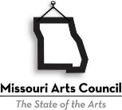
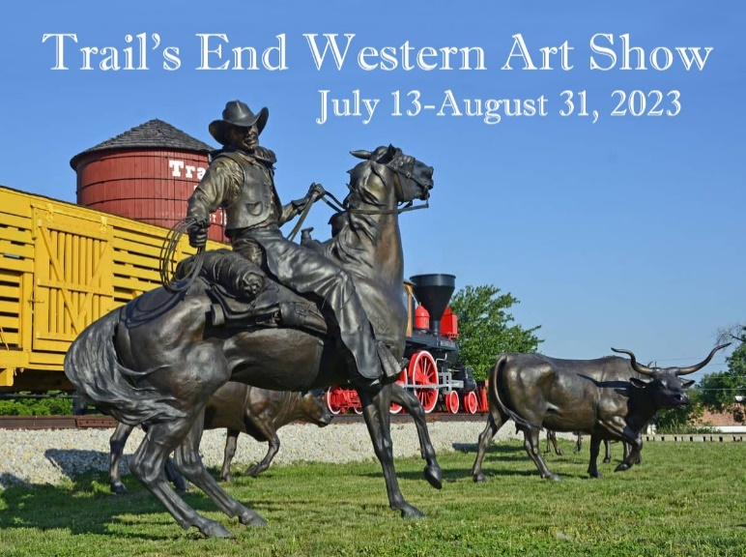

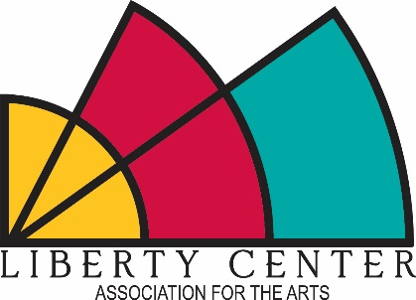

The intention of the Trail’s End Western Art Show is to exhibit art which draws inspiration from the American West and can include both historic and contemporary themes and imagery.

In the 19th century, Sedalia, Missouri was known as the Trail’s End or last stop for the cowboys and wranglers who worked the great western cattle drives which brought beef to the railhead and thence to markets in the east. Without the railroad there would have been no Sedalia, but the area is also rich in pioneer and Native American history. Missouri was the starting point for the Lewis and Clark expedition in 1804, the Emigrant Trail, and the Westward movement beginning in the 1850s.

Today, Sedalia has a Trail’s End Monument at the junction of south Highway 65 and 16th Street which celebrates this history. This art exhibit will be a contemporary reflection of Sedalia’s history, the indomitable spirit of the cowboy, the legend of the cattle drives, and the beauty of the landscape.

ELIGIBILITY: The Trail’s End Western Art Show is open to any artist 21 years of age or older. All artwork must be the original work of the submitting artist and created during the last three years. Commercial duplications of prints or drawings will not be accepted.

SPECIFICATIONS: Any two-dimensional or three-dimensional media is eligible. All work must be ready to hang with an appropriate device. Maximum size is 60” in length, width, and height. Three-dimensional work must be able to pass through a standard doorway. There is a 150-pound maximum for all works. No artwork may be suspended from the ceiling.

AWARDS: $2,000 in cash awards will be presented. $1,000 for the Best of Show award and two $500 Merit awards.

JUROR: Grant Kniffen retired in 2013 after teaching 27 years at Parkway North High School in Saint Louis, Missouri. He received his B.S.E. in Art from Truman State University in 1984 and his Masters in Studio Art from Lindenwood University in 1989. In 1995, Grant was selected Secondary Art Teacher of the Year by the Missouri Art Education Association. He was Parkway School District's High School Teacher of the Year during the 1996-97 school year. Kniffen's work is rooted in American and regional themes. While his early work was in traditional realism, his current work is a blend of realism and early twentieth century Modernism. Grant Kniffen's artwork has been recognized with numerous awards and resides in public and private collections.

LOCATION/SPONSOR: The Liberty Center Association for the Arts will host the Trail’s End Western Art Show in three galleries at the Hayden Liberty Center, 111 West 5th, downtown Sedalia, Missouri. More information about the Liberty Center Association for the Arts (LCAA), a non-profit arts organization housed within the historic Hayden Liberty Center, can be found on our Facebook page or on our website at www.libertycentersedalia.com.

REQUIRED FOR ENTRY

ENTRY FEE: A fee of $30 will allow the entry of one or two works. This fee can be paid online at https://app.arts-people.com/index.php?retail=lcafa. Choose “View Details” for the Trail’s End Western Art Show and then add a quantity of 1 to the cart and check out. Entry fees can also be paid with credit card by calling the Liberty Center Association for the Arts at 660-827-3228, Tuesday-Saturday from 1-5 p.m., or by delivery of check or cash to the Liberty Center box office. Entry fees are non-refundable. Checks should be made to LCAA (Liberty Center Association for the Arts).

Include all required artist information in the body of one email. Images, artwork, and artist info emailed to ruthie@libertycentersedalia.com by May 18, 2023.

JPEG/DIGITAL IMAGE (UP TO TWO WORKS OF ART MAY BE SUBMITTED PER ENTRY FEE)

Images submitted as JPEG file format only. NO .png or .tiff files, please.

High-resolution JPEG files preferred with file size minimum of 1MB and not to exceed 3MB.

Please make sure that your digital image is: sharp and in focus; cropped to feature only your artwork, and free of any time-date stamp.

Please re-name your JPEG image files with your last name and one word from the artwork title -- Example: Jones.Apples.jpg.

Include JPEG images as attachment to one email. Please do not embed jpeg files in a document. Do not send folders or other materials. Do not send multiple emails.

ARTWORK INFO FOR EACH WORK SUBMITTED

Artwork title

Year completed - only works created in 2020, 2021, 2022, or 2023 are eligible for consideration

Media & surface - (Example: oil on canvas; graphite on paper; digital photograph on paper)

Artwork dimensions - height x width x depth

Sale price or if not for sale, list as NFS; Artwork must either have a sale price or be listed as NFS (Not For Sale). We will not list artworks as POR (Price on Request).

Optional: Artist’s statement about your specific artwork entries. Limit 70 words in first person point-of-view. Include statement in the body of your email—no attachments. Please be clear as to which artwork your statement is referring.

ARTIST INFO

Artist name (If you use an alias or 'artist' name, please specify the correct name for us to use for exhibition purposes)

Mailing address, city, state, zip code and phone number

Email address and website and/or social media links for Instagram, Facebook, or Twitter if desired
JURYING PROCESS and FINAL SELECTION

This exhibit will be juried from JPEG images submitted by email.

Submittal of artwork does not guarantee selection for this juried exhibition.

A juried exhibit is a competitive process.

Artworks selected for this exhibit are at the Juror’s discretion. The juror reserves the right to remove an unacceptable entry during the final judging.

Accepted works which differ significantly from the submitted photograph will be disqualified.

DELIVERY: Accepted entries may be hand delivered or shipped to the Hayden Liberty Center/Liberty Center Association for the Arts, 111 West 5th Street, Sedalia, MO 65301. Please allow ample time for entries to reach us. Artists will be responsible for all shipping or delivery cost. Hand-delivered works will be accepted between the hours of 1-5 p.m. on July 1, 6, 7, or 8. All must arrive by July 8, 2023.

OPENING RECEPTION: The artist’s reception will be held in the galleries at the Hayden Liberty Center, 111 West 5th Street, Sedalia, Missouri on July 13, 2023 from 6-8 p.m.

SALES: Artists are encouraged to list their works for sale. The LCAA will retain a 30% commission of the selling price on all sales during the exhibition. Payments for all works sold will be made to the artist on or before September 5, 2023.

LIABILITY: Utmost care in handling will be given to all entries. However, the Liberty Center Association for the Arts (LCAA) will assume no responsibility for the loss or damage to any work entered. All individuals working with this exhibition shall be held blameless for any and all liabilities arising from this exhibition. The LCAA shall assume the right to reproduce any entry for publicity purposes related to this exhibition and for future exhibitions. The return of the entry form constitutes the artist's agreement with conditions set forth in this agreement.

IMPORTANT DATES

May 18, 2023: Deadline to receive artwork entries. Images (along with artwork and artist information) need to be sent by email to doug@libertycentersedalia.com. Entry fee needs to be paid at the following link- https://app.arts-people.com/index.php?retail=lcafa or through the Hayden Liberty Center box office Tuesday- Saturday from 1-5 p.m.

June 8, 2023: Notification of juror selections sent via email by this date.

July 8, 2023 by 5 p.m.: Shipped or delivered artwork must be received at the Hayden Liberty Center, 111 West 5th, Sedalia, MO 65301.

July 13, 2023, 6-8 p.m.: Opening reception for exhibition.

August 31, 2023: Exhibition closes; return of shipped work within 10 business days.

September 1-3, 2023, 1-5 p.m.: Pick up of hand-delivered work.

